**PRACTICAL – 3**

**AIM:**

|  |
| --- |
| **Exchange the contents of memory locations 2000H and 4000H** |

**CODE:**

ORG 100H

ORG 100H

MOV [4000H],32H

MOV [2000H],16H

MOV AX,[4000H]

MOV BX,[2000H]

MOV [4000H],BX

MOV [2000H],AX

RET

**OUTPUT:**

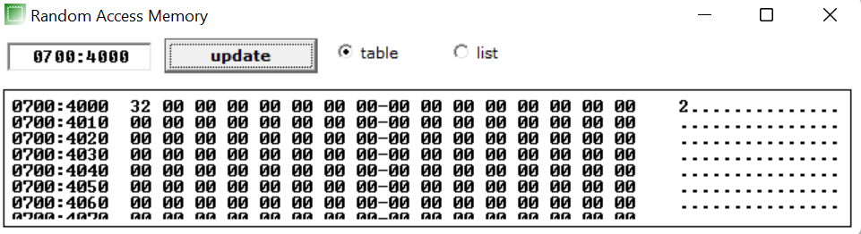

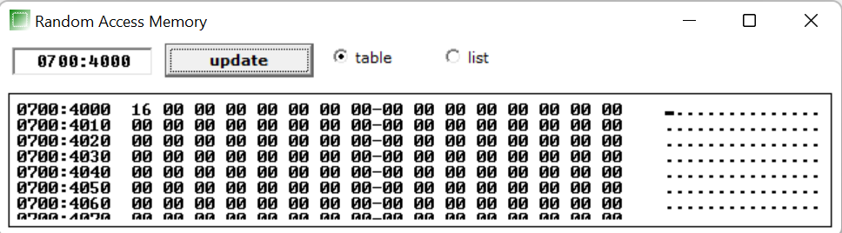

**CONCLUSION:** In this practical we learnt to exchanged contents one memory location into another memory location.